# R Programming Challenge

## Submission by Poonam Nanda

### Glucose Dataset: Questions

Q1. Using "glucose_data.csv" plot Glucose vs Time graph for the entire dataset

Q2. For the given dataset plot the Glucose Levels for “1st October”

Q3. Calculate the average Glucose Level of the patient for each day in the dataset. (Hint :

Average Glucose for 3rd Oct and 7th Oct is 123 and 140 respectively)

Solution:

Code : 

Output :

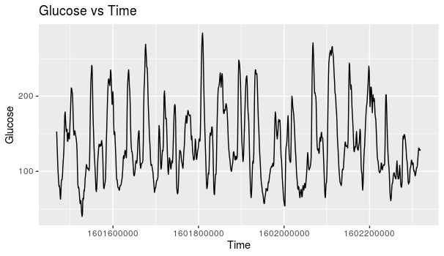

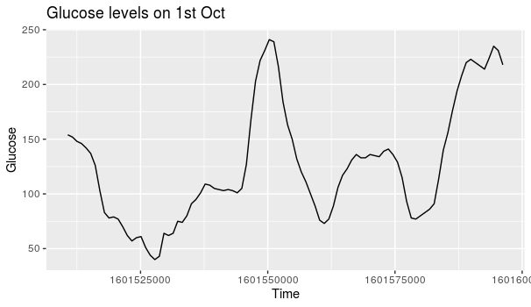

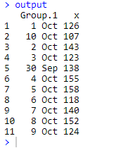

### Iris Dataset : Question

### Q4. Using Iris dataset, plot the following graph (Hint : ggplot – color by species)

Solution

Code : 

Output :

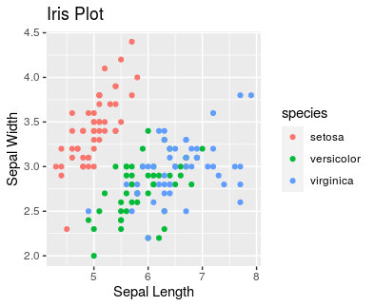

### Kaggle Crime Data : Questions

Using Kaggle Crime Data data plot the following graphs (3 sub parts) (Hint : group_by and summarise)

Solution:

Code : 

Output : 